Problem Decomposition
To-Do-List With Deadlines
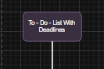

1️) Login System
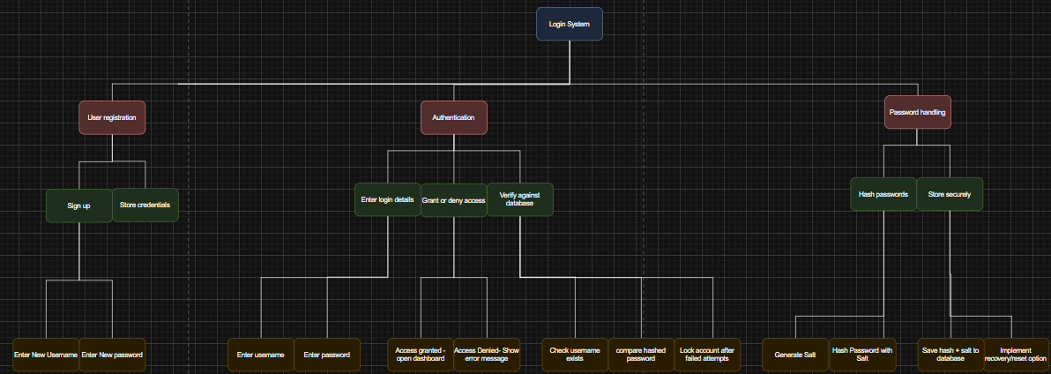
Login System (Parent Module) – Manages all login-related functionality, ensuring secure and personalised access for students.
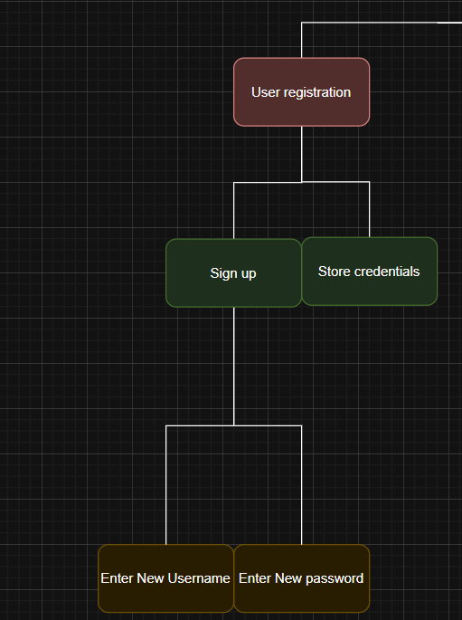
User Registration (Child) – Enables new students to create accounts.

Sign Up – Allows the user to register to the app
  - Enter new username – Student chooses a unique login name.
  - Enter new password – Student sets a secure password.

Store credentials – Saves username and hashed password securely.

Store securely – Saves sensitive data in a protected way.
  - Store hash + salt in the database – Keeps credentials safe instead of storing plain text passwords.
  - Implement recovery/reset option – Allows students to reset forgotten passwords using security questions or email verification.
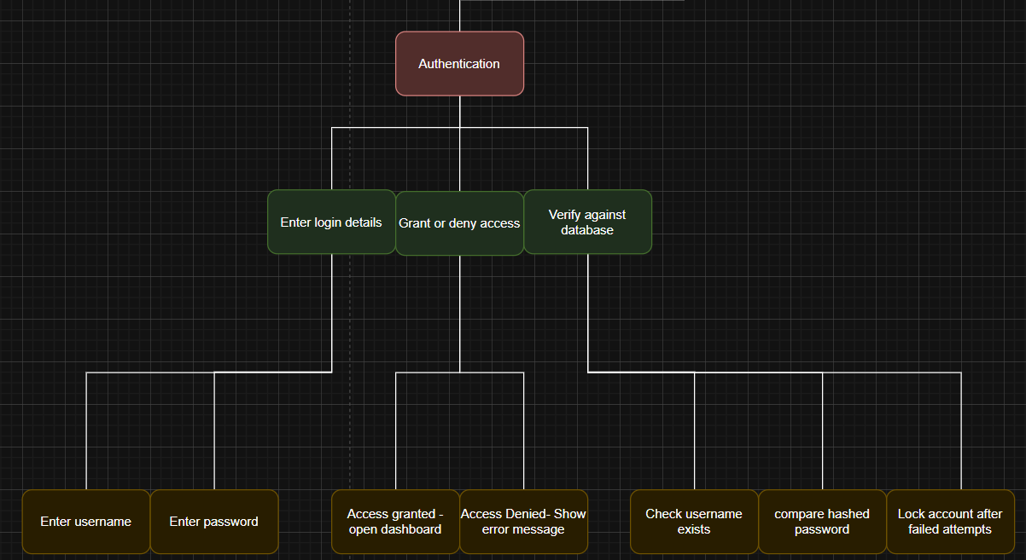
Authentication (Child) – Verifies users and grants or denies access.
- Enter login details – Users input their credentials to access the system.
  - Enter username – User enters the same username they signed up with
  - Enter password – User enters the same password they created when signing up

- Grant or deny access – Logs the user in if credentials match; otherwise denies access.
  - Check username exists – Confirms that the entered username is registered.
  - Compare hashed password – Checks whether the inputted password matches the stored hash.
  - Lock account after failed attempts – Protects against brute-force attacks.

- Verify against database – Check whether the entered credentials match stored records.

  - Check username exists – Confirms that the entered username is registered.
  - Compare hashed password – Checks whether the inputted password matches the stored hash.
  - Lock account after failed attempts – Protects against brute-force attacks.
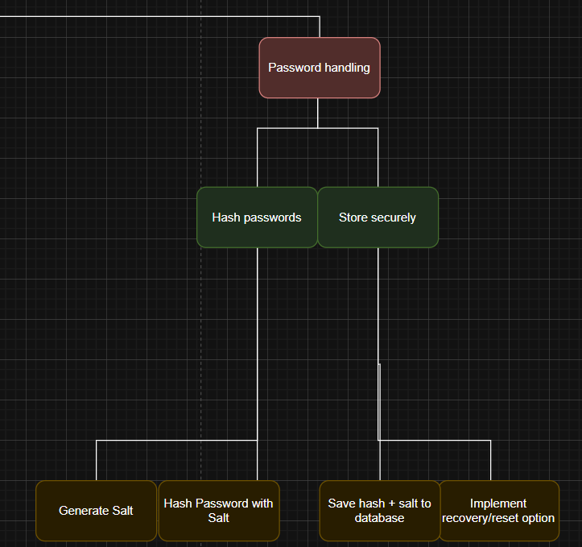

Password Handling (Child) – Ensures all passwords are stored securely, preventing unauthorised access.
- Hash passwords – Converts the user’s password into a secure, unreadable format before storing it.
  - Generate salt – Creates a unique random value combined with the password before hashing to prevent dictionary attacks.
  - Hash password using algorithm – Converts password + salt into a secure, irreversible hash.
How this module will be implemented and where
User credentials are stored as records containing a user ID, username, password, password hash and salt. During the registration process, a random salt is generated, combined with the password, and hashed before being saved. During the authentication stage, the system retrieves the stored salt for the entered username, hashes the input password using the same algorithm and compares the result with the stored hash. Conditional checks determine whether access is granted, denied, or the account is locked after a certain amount of constant failed attempts.

2️) Task Management
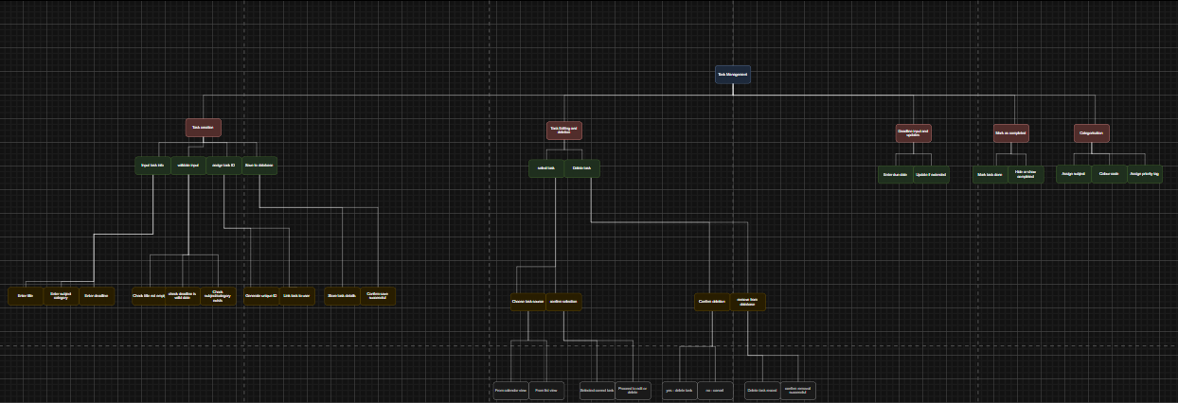
Task Management (Parent Module) – Central system for creating, editing, deleting, and organising tasks.
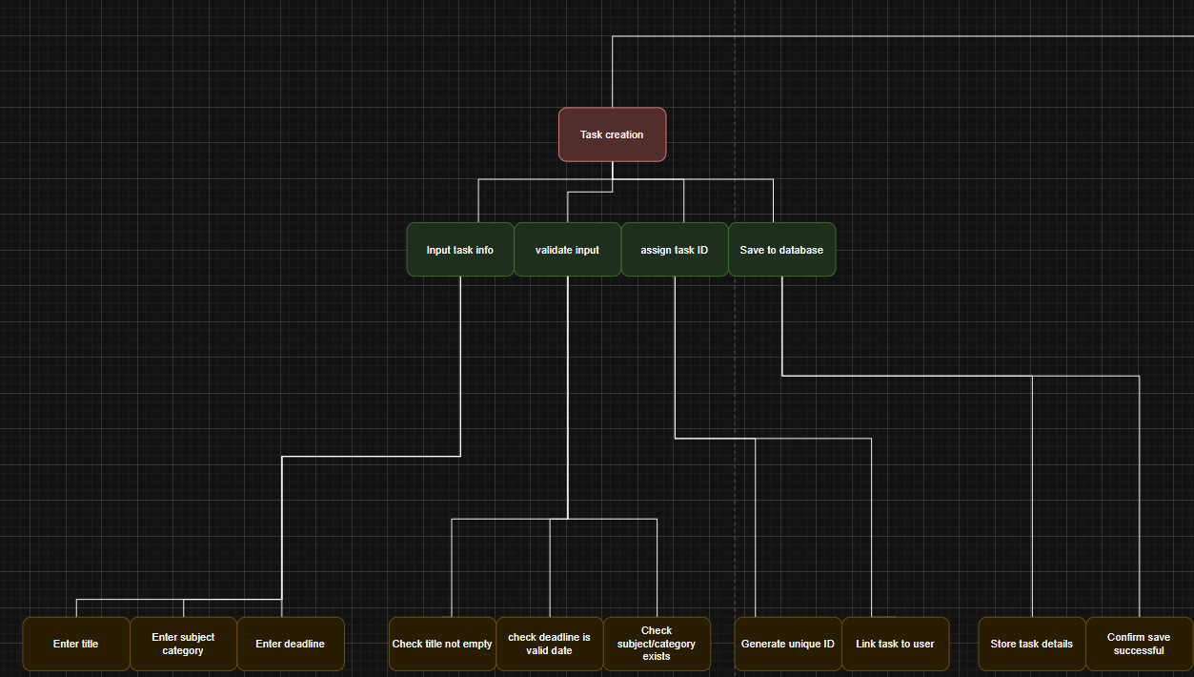
Task Creation (Child) – Adds new tasks with deadlines and subject information.

- Input Task Info – User enters details for the task.
  - Enter Title – The name of the task.
  - Enter Subject/Category – The subject or category the task belongs to.
  - Enter Deadline – The due date for the task.
- Validate Input – System checks the data entered is correct.
  - Check Title Not Empty – Ensures the task has a name.
  - Check Subject/Category Exists – Confirms the subject/category is valid.
  - Check Deadline Is Valid – Makes sure the deadline is a real date.
- Assign Task ID – Gives the task a unique identifier.
  - Generate Unique ID – Creates a number/code that is unique to the task.
  - Link Task to User – Connects the task to the specific student account.
- Save to Database – Stores the task permanently.
  - Store Task Details – Saves all entered and validated information.
  - Confirm Save Successful – Notifies the user that the task has been saved.

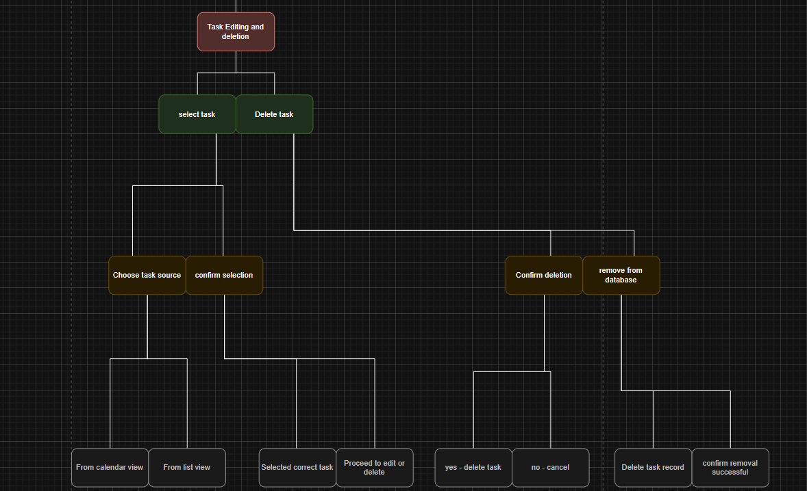
Task Editing & Deletion (Child) – Process of updating or removing tasks.
- Select Task – User chooses which task to work on.
  - Choose Task Source – Decide where the task is selected from.
    - From Calendar View – Pick a task directly from the calendar layout.
    - From List View – Pick a task from the task list.
  - Confirm Selection – Ensure the correct task was chosen.
    - Selected Correct Task – Confirms the right task is highlighted.
    - Proceed to Edit or Delete – Moves to editing or deleting the task.
- Delete Task – User removes the chosen task.
  - Confirm Deletion – System asks for confirmation before deleting.
    - Yes → Delete Task – Continues with deletion.
    - No → Cancel – Stops the deletion process.
  - Remove from Database – Task is permanently erased.
    - Delete Task Record – Removes the task entry from storage.
    - Confirm Removal Successful – System confirms deletion was completed.
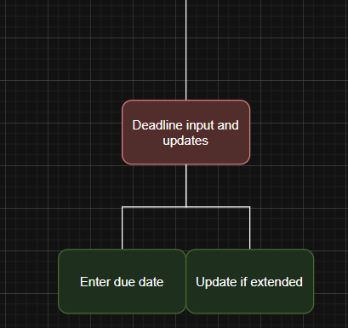
Deadline Input & Updates (Child) – Manages task deadlines.
- Enter Due Date – User sets the initial deadline when creating a task.
- Update if Extended – User adjusts the deadline if more time is given.
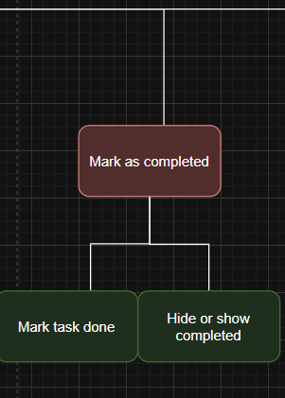
Mark as Completed (Child) – Allows users to finish and manage completed tasks.
- Mark Task Done – Marks the selected task as finished.
- Hide or Show Completed – Lets the user choose whether completed tasks are visible or hidden.
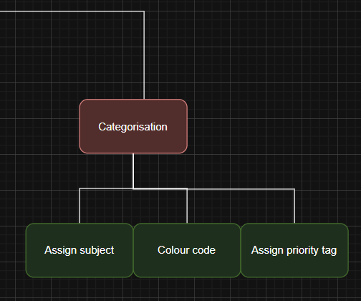

Categorisation (Child) – Organises tasks visually and logically.

  - Assign subject – Groups tasks by subject.
  - Assign priority tag – Indicates importance and urgency.
  - Assign colour code – Visual identification of tasks.

How this module will be implemented and where
Each task is stored as a structured record containing a unique task ID, title, subject, deadline, priority value and completion status. When tasks are edited or deleted, the system searches for the matching task ID within the user’s task list and updates or removes only that record. Validation checks are applied at the point of task creation and editing to prevent empty fields or invalid dates from being saved. Completion status is stored as a Boolean value and used to filter visible tasks.

3️) Priority Algorithm
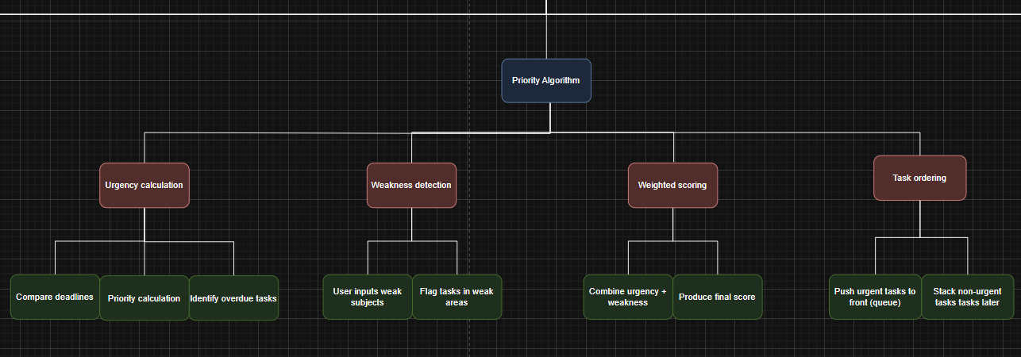
Priority Algorithm (Parent Module) – Determines which tasks should be completed first based on urgency and weakness.
Urgency Calculation (Child) – Determines which tasks need attention first.
- Compare Deadlines – Check how close each task is to its due date.
- Identify Overdue Tasks – Detect tasks that have passed their deadlines.

Weakness Detection (Child) – Finds tasks in subjects where the user struggles.
- User Input Weak Subjects – User indicates topics they find difficult.
- From Past Tasks/Tests – Identify weaknesses based on previous performance.
- Flag Tasks in Weak Areas – Mark tasks that target weak subjects for prioritisation.

Weighted Scoring (Child) – Combines urgency and weakness to rank tasks.
- Combine Urgency + Weakness – Merge importance based on deadline and subject difficulty.
- Produce Final Score – Assign a numerical score to determine priority.

Task Ordering (Child) – Arranges tasks based on priority.
- Push Urgent Tasks to Front (Queue) – High-priority tasks appear first.
- Stack Non-Urgent Tasks Later – Low-priority tasks are scheduled after urgent ones.

How this module will be implemented and where

The system iterates through the user’s task list using a loop. For each task, urgency is calculated by comparing the current date to the stored deadline, with overdue tasks assigned the highest urgency value. A weakness score is added at this stage if the task’s subject appears in the user’s “weak subject” list. These values are combined to generate a final numerical priority score and the task list is then sorted in descending order so that higher priority tasks appear first.

4️) Revision Planning
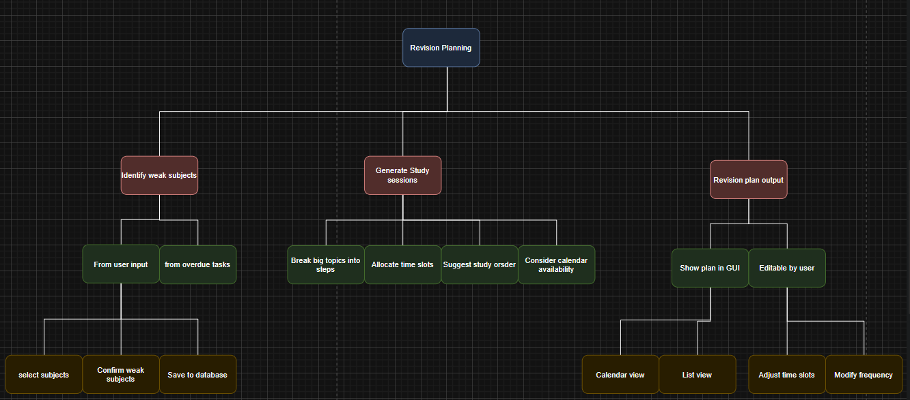
Revision Planning (Parent Module) – Creates structured study sessions tailored to student needs.
Identify Weak Subjects (Child) – Determines areas where the student needs extra practice.
- From User Input – Student selects subjects they struggle with.
  - Select Subjects – Pick topics considered weak.
  - Confirm Weak Areas – Ensure chosen subjects are accurate.
  - Save to Database – Store weak subjects for use in planning.
- From Overdue Tasks – Identify weaknesses based on incomplete tasks.

Generate Study Sessions (Child) – Creates a structured revision timetable.
- Break Topics into Steps – Divide subjects into smaller, manageable chunks.
- Allocate Time Slots – Assign study sessions to specific times.
- Consider Calendar Availability – Avoid scheduling conflicts with other tasks.
- Suggest Study Order – Recommend the most efficient sequence for studying.

Plan Output (Child) – Displays and allows editing of revision plans.
- Show in GUI – Present revision plan visually.
  - Calendar View – Tasks shown on a calendar layout.
  - List View – Tasks shown as a simple list.
- Editable by User – Users can adjust the plan.
  - Adjust Time Slots – Change when each study session occurs.
  - Modify Frequency – Change how often sessions repeat.

How this module will be implemented and where
Weak subjects are stored in a list linked to the user’s profile. The system iterates through this list to break each subject into smaller topics and assigns them to available time slots in the user’s calendar. Existing tasks are checked at this stage to avoid scheduling clashes. Sessions for weaker subjects are allocated longer or more frequent time blocks and generated sessions are saved and displayed for user editing.
5️) Notification System
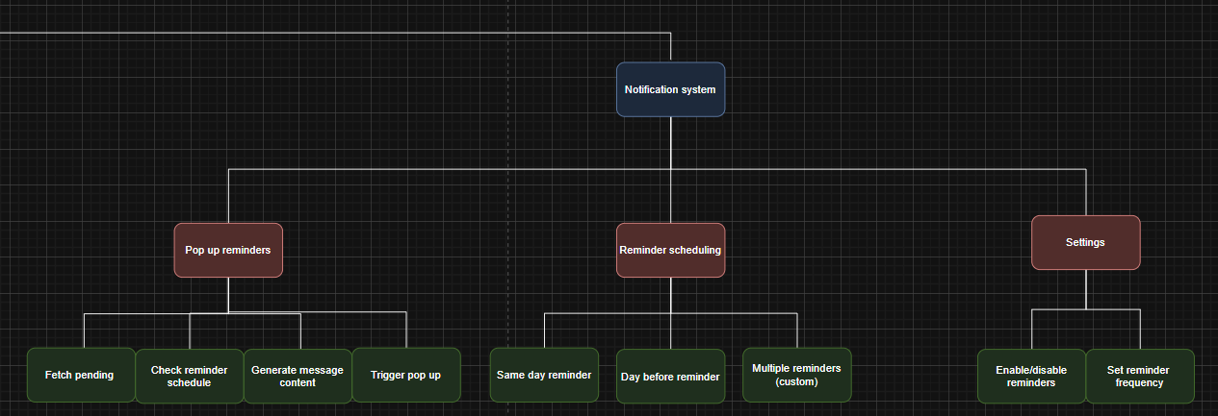
Notification System (Parent Module) – Alerts students about tasks and deadlines to reduce missed work.
Pop-up Reminders (Child) – Alerts users about upcoming tasks.
- Fetch Pending Tasks – Collect tasks that need reminders.
- Check Reminder Schedule – Determine when each reminder should appear.
- Generate Message Content – Create clear, concise notification messages.
- Trigger Popup – Display the reminder on the user’s screen.

Reminder Scheduling – Controls when reminders are sent.
- Same-Day Reminder – Alert the user on the day the task is due.
- Day-Before Reminder – Notify the user one day before the deadline.
- Multiple Reminders (Customisable) – Allow several alerts based on user preference.

Settings (Child) – Lets users customise notification behaviour.
- Enable/Disable Reminders – Turn notifications on or off.
- Set Reminder Frequency – Adjust how often reminders are sent.

How this module will be implemented and where

A background process regularly checks stored tasks by comparing their deadlines with the current date and time. Conditional logic determines whether reminder conditions are met, such as a task being due on the same day or the following day. If conditions are satisfied and notifications are enabled in user settings, a reminder message is generated and displayed as a windows styled pop up.

6️) Graphical User Interface (GUI)
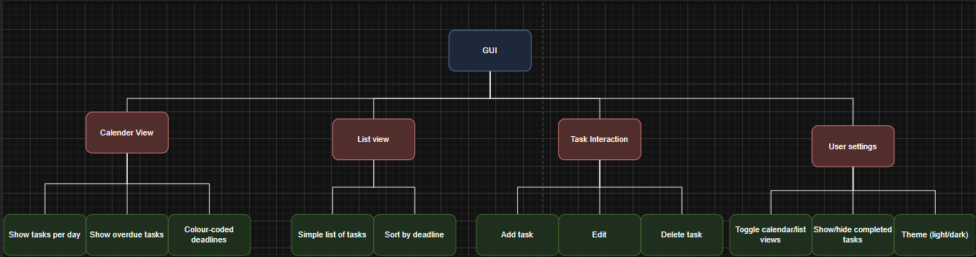
GUI (Parent Module) – Displays tasks, revisions, and notifications visually for ease of use.
Calendar View (Child) – Displays tasks in a visual calendar format.
- Show Tasks Per Day – Lists all tasks scheduled for each day.
- Show Overdue Tasks – Highlights tasks past their deadlines.
- Colour-Coded Deadlines – Uses colours to indicate urgency or priority.

List View (Child) – Presents tasks in a simple, ordered list.
- Simple List of Tasks – Displays all tasks sequentially.
- Sort by Deadline – Orders tasks by their due dates.

Task Interaction (Child) – Lets users manage tasks through the interface.
- Add Task – Open form to create a new task.
- Edit Task – Select and modify an existing task.
- Delete Task – Remove a task from the system.

User Settings (Child) – Allows customisation of the GUI.
- Toggle Calendar/List View – Switch between calendar and list formats.
- Show/Hide Completed Tasks – Choose whether finished tasks are visible.

How this module will be implemented and where

Task and revision data is retrieved from the database via the Database and data storage module and rendered dynamically in either calendar or list format. Priority values calculated by the Priority Algorithm are mapped to colours at this stage to visually highlight urgent tasks. When a user adds, edits or deletes a task through the interface, the underlying data structures are updated and the display is refreshed to maintain consistency.

7️) Database and Data Storage
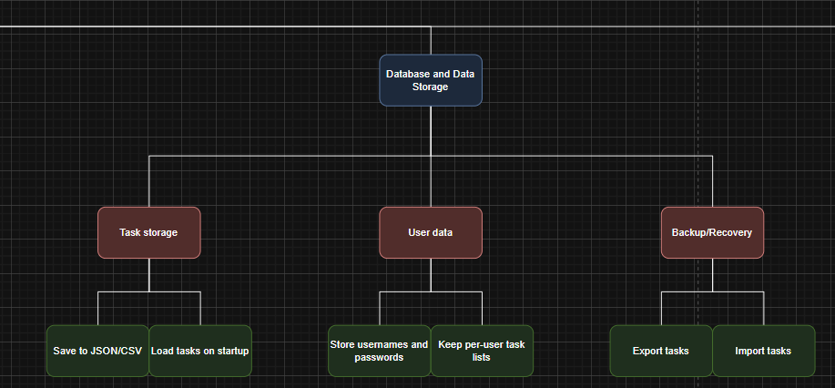
Database & Data Storage (Parent Module) – Stores all tasks and user information reliably.

Task Storage (Child) – Manages how tasks are saved and loaded.
- Save to JSON/CSV – Stores tasks in structured file formats for easy access.
- Load Tasks on Startup – Automatically retrieves saved tasks when the system starts.

User Data (Child) – Handles storage of user-related information.
- Store Usernames & Passwords – Keeps login details securely for authentication.
- Keep Per-User Task Lists – Ensures each user only sees their own tasks.

Backup & Recovery (Child) – Provides safety and reliability for stored data.
- Export Tasks – Allows users to save a backup copy of their tasks externally.
- Import Tasks – Lets users restore tasks from a saved file if needed.

How this module will be implemented and where

All user and task data is stored persistently in a structured database. When the system starts, this data is loaded from the database into memory as lists or tables so it can be processed efficiently by algorithms. Changes made during use are written back to the database, ensuring data is preserved between sessions. This provides reliability without requiring manual backup from the user.
Justification
The main problem this project addresses is that students aged 12–18 often struggle to manage multiple tasks and deadlines. Procrastination, poor prioritisation and unorganised revision can lead to stress, gaps in learning and lower grades. Existing tools like Google Classroom or Microsoft Teams track tasks but do not provide personalised reminders, priority-based scheduling, or revision plans based on a student’s weaknesses. This project, a To-Do List with Deadlines, aims to help students organise tasks, track deadlines, prioritise work and plan structured revision. To achieve this, the system is broken into smaller, manageable modules that focus on different parts of the problem.
Breaking the project into modules simplifies complexity, makes the system clearer and makes coding and testing easier. Each module focuses on a specific feature, either for the user or in the backend. For example, separating Task Creation from Task Editing and Deletion ensures that validation, storage, and interface logic work correctly for each function. Modular design also allows features like notifications or GUI components to be reused and extended in the future without major changes.
The Login System is the first key module, allowing secure and personalised access. It is split into User Registration, Authentication and Password Handling. User Registration manages account creation and verification. Authentication checks credentials, confirms username existence, compares hashed passwords, and locks accounts after failed attempts. Password Handling secures credentials, hashes passwords with a salt and allows recovery options. This ensures strong security while letting students access their tasks safely.
The Task Management module covers creating, editing, deleting and organising tasks. Task Creation lets students input task details, validates them, generates unique task IDs and saves them. Task Editing & Deletion allows selection from calendar or list views, making changes or deleting tasks safely. Deadline Input and Updates manages task due dates, Mark as Completed tracks finished tasks, and Categorisation groups tasks by subject, priority and colour. Breaking this down ensures accuracy, reduces mistakes and makes the interface easy to use.
The Priority Algorithm decides which tasks need attention first. It includes Urgency Calculation (checks deadlines), Weakness Detection (highlights subjects the student struggles with), Weighted Scoring (combines urgency and weakness into a numerical score), and Task Ordering (ranks tasks by priority). This structure keeps prioritisation logic clear, reliable and adaptable.
Revision Planning helps students plan structured study sessions. It includes identifying weak subjects, generating study sessions by splitting topics and assigning time slots based on the student’s calendar, and showing the plan in a calendar or list view. The plan is editable, allowing students to adjust times and frequency. This breakdown produces actionable revision plans while giving flexibility.
The Notification System alerts students about upcoming tasks. Pop-up Reminders fetch tasks, create messages and display notifications. Reminder Scheduling controls when alerts appear, supporting same-day, day-before, or multiple reminders. Settings let students turn reminders on/off and adjust frequency or style. Separating this module makes reminder logic easier to manage.
The Graphical User Interface displays tasks, revision plans, and notifications visually. Calendar View shows tasks by day with colour-coded deadlines and overdue tasks. List View shows tasks in order. Task Interaction allows adding, editing or deleting tasks. User Settings manage view type, visibility of completed tasks, and theme or accessibility options. Modular GUI design keeps the interface user-friendly, responsive and maintainable.
Finally, the Database & Data Storage module manages all saved information. Task Storage handles saving and loading tasks. User Data stores login credentials and per-user task lists. Backup and Recovery allows exporting and importing tasks while handling conflicts. Splitting storage into submodules improves reliability, reduces errors and separates database logic from the rest of the system.
Overall, decomposing the system allows each problem- security, task management, prioritisation, revision planning, notifications, interface design, and data storage- to be handled efficiently. Modules make the project easier to implement, test and extend. The modular design ensures students have a secure, personalised and easy-to-use system to organise tasks, meet deadlines and optimise their study time effectively.

